1)

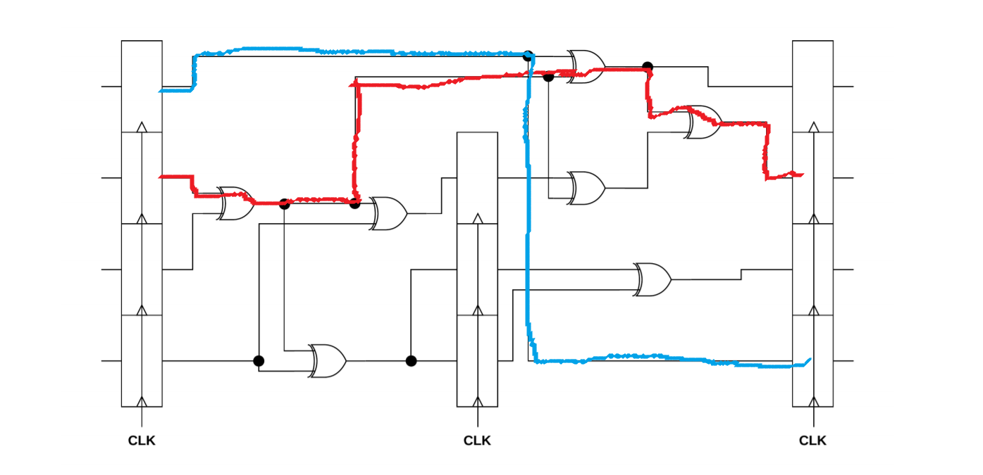

a)

Tc >= Tpcq + Tpd(max) + Tsetup

Tc >= Tpcq + 3\*Tpd + Tsetup

Tc >= 70 + 3\*60 + 60 = 310ps

Max Frequency = 1s/T = 1/(310ps) = 3.226 GHz

b)

Tccq + Tcd(min) >= Thold + Tskew

50 + 0\*40 >= 20 + Tskew

Tskew <= 30

2)

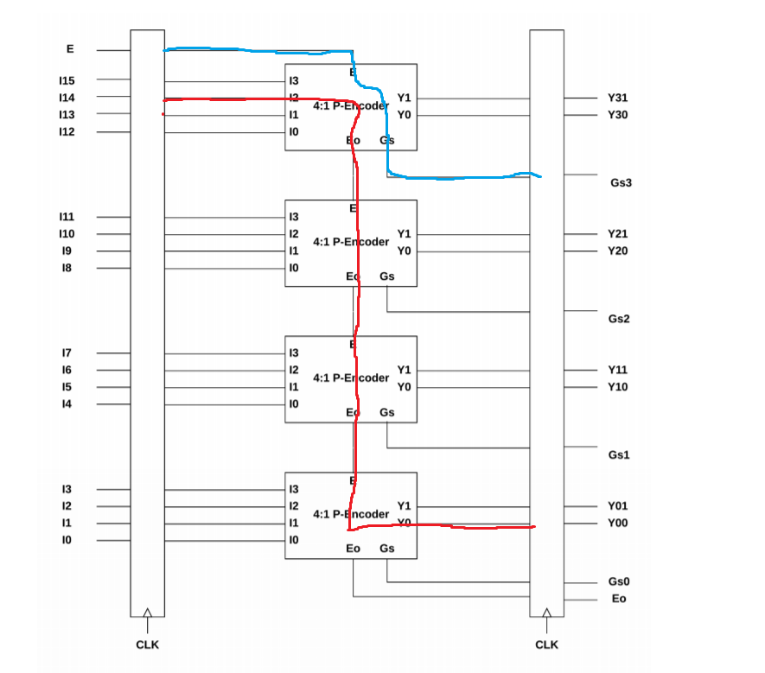

a)

Tc >= Tpcq + Tpd(max) + Tsetup

Tc >= 35 + (30 + 20 + 20 + 25) + 30

Tc >= 160ps

Max Frequency = 1s/T = 1/(160ps) = 6.25 GHz

b)

Tccq + Tcd(min) >= Thold + Tskew

25 + (10) >= 10 + Tskew

Tskew <= 25

3)

3.1)

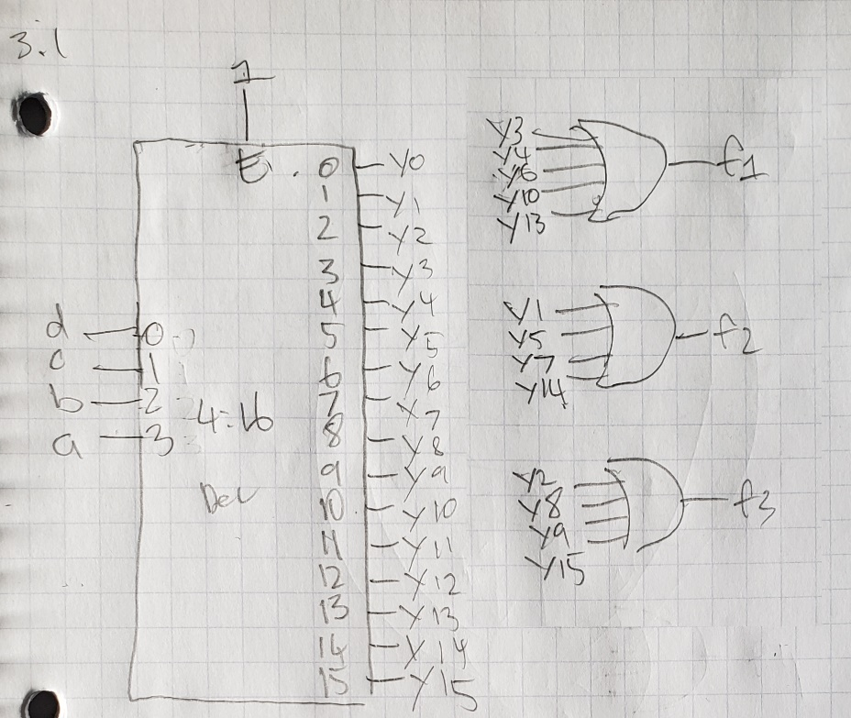

3.2)

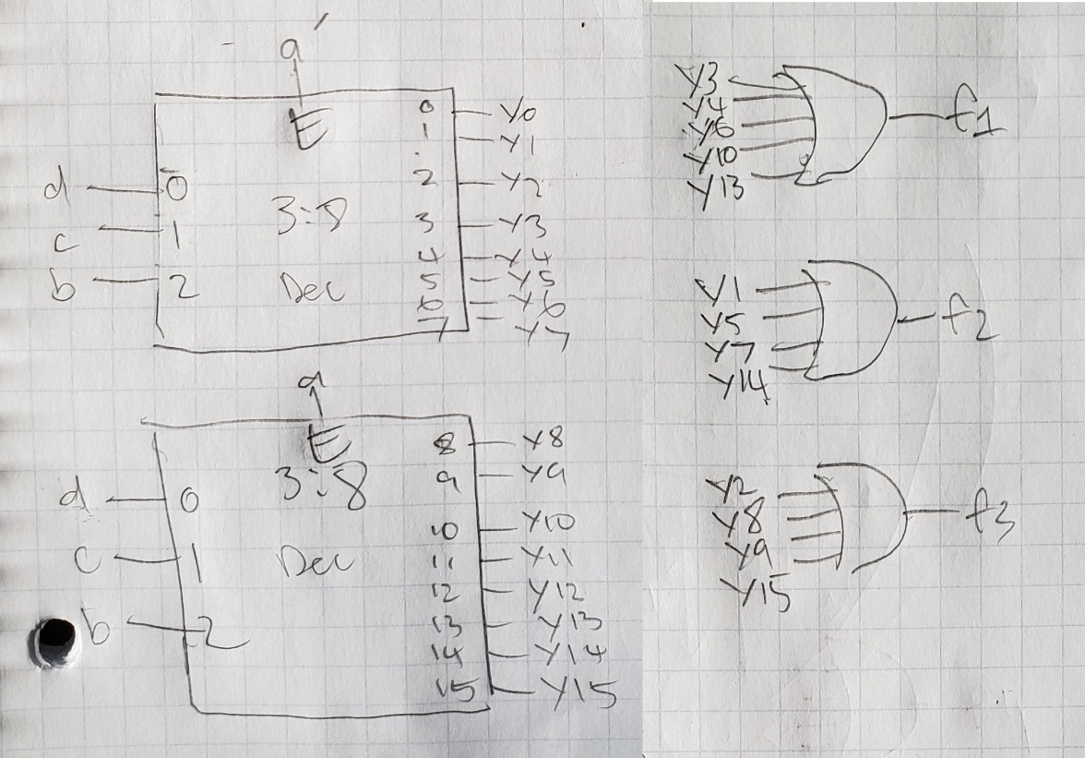

3.3)

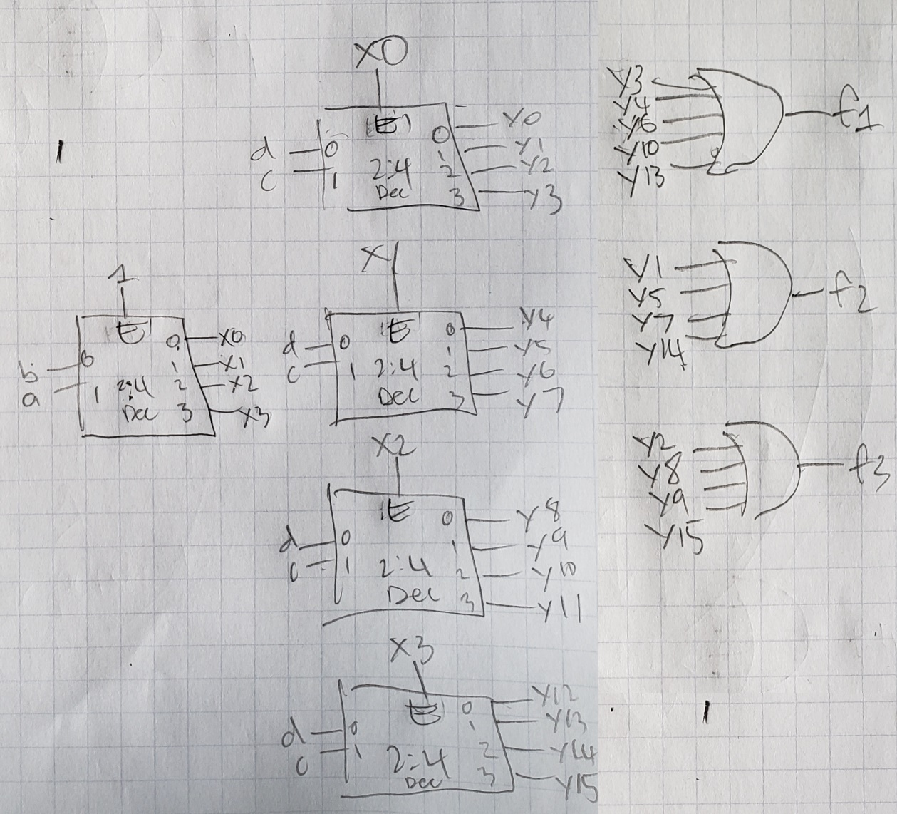

4)

4.1)

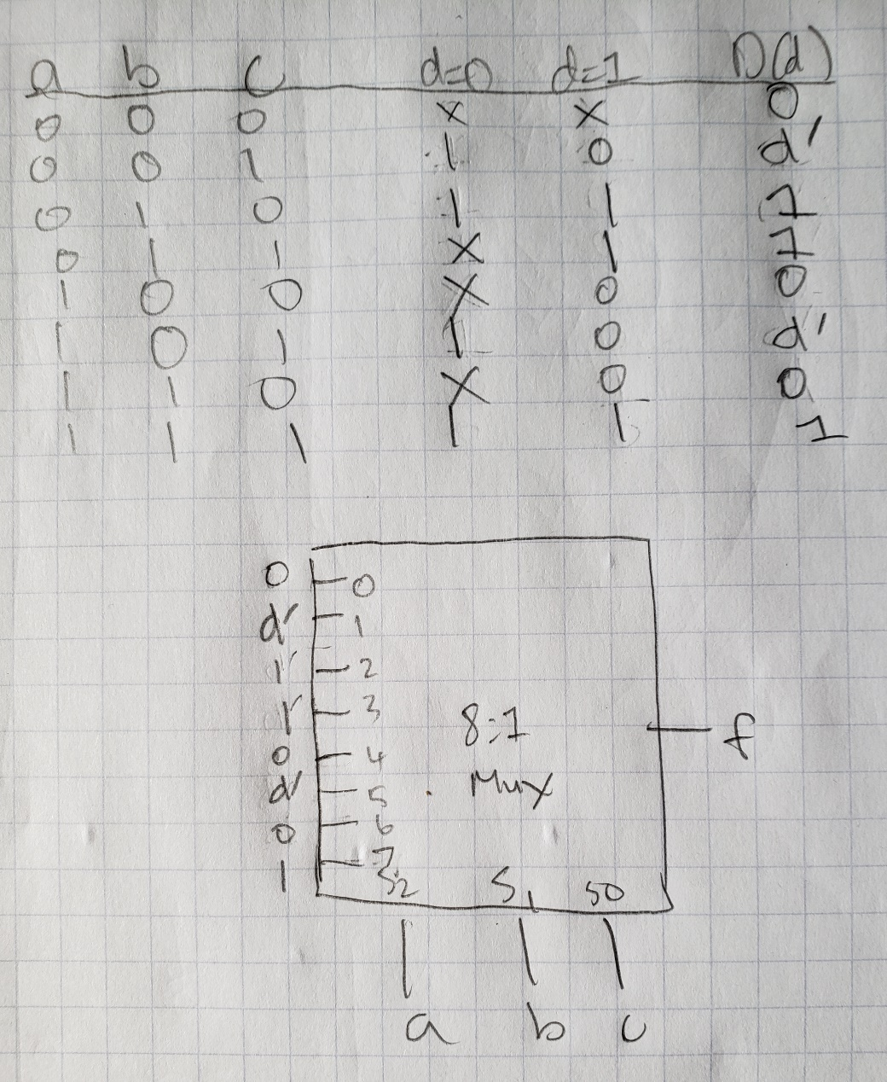

4.2)

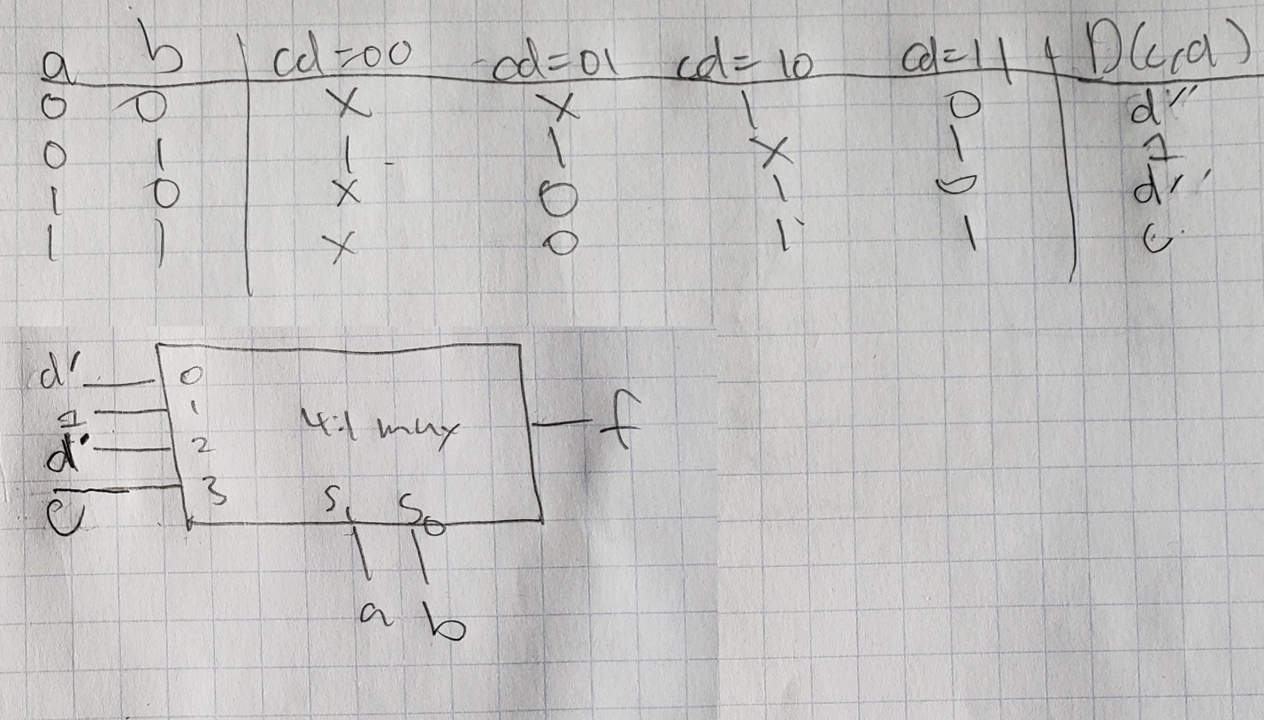

4.3)

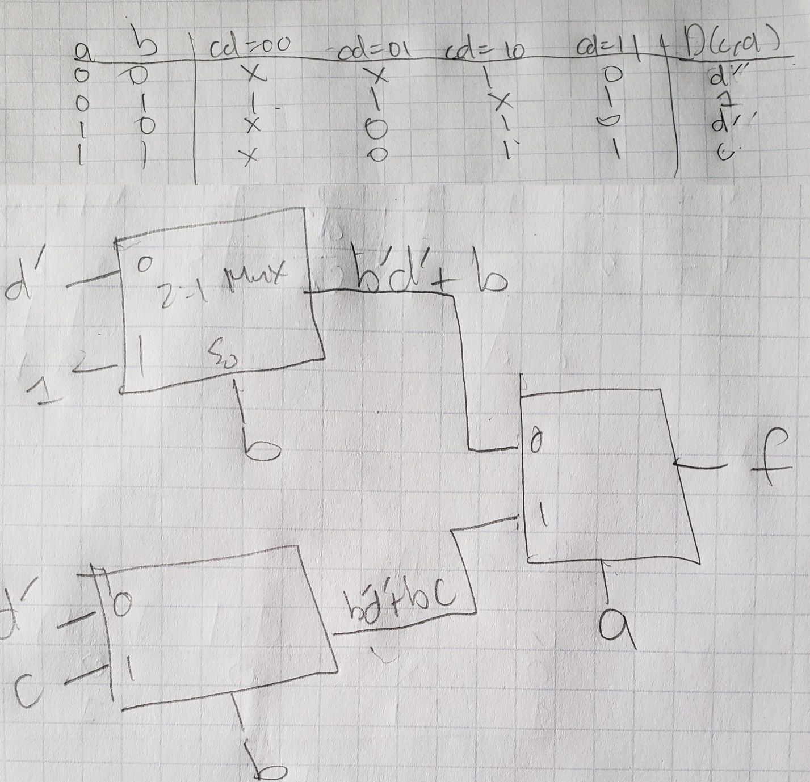

5)

5.1)

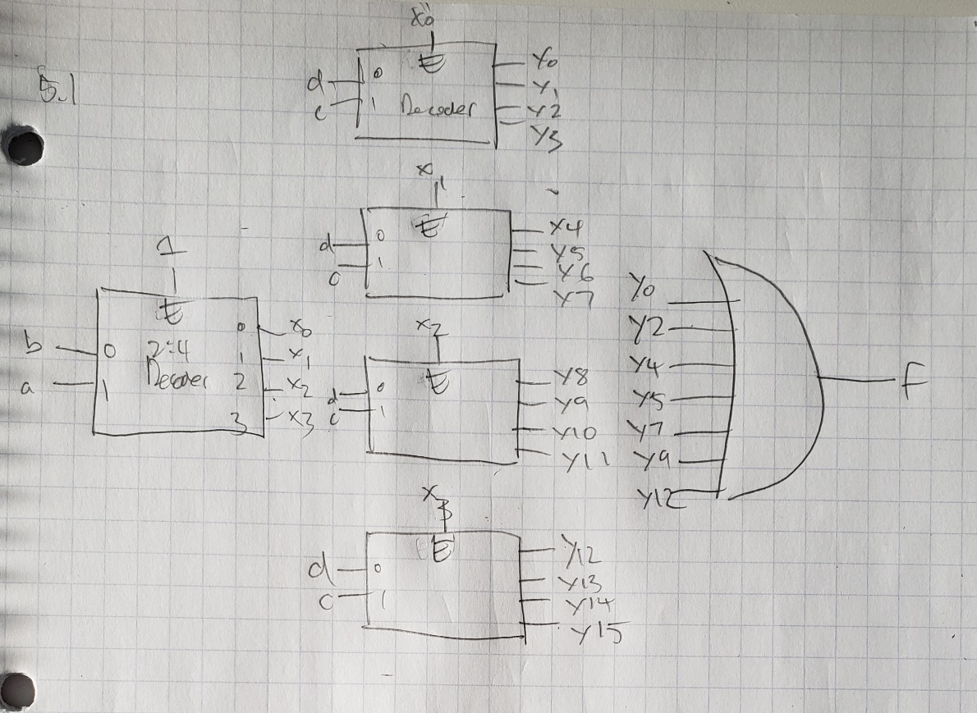

5.2)

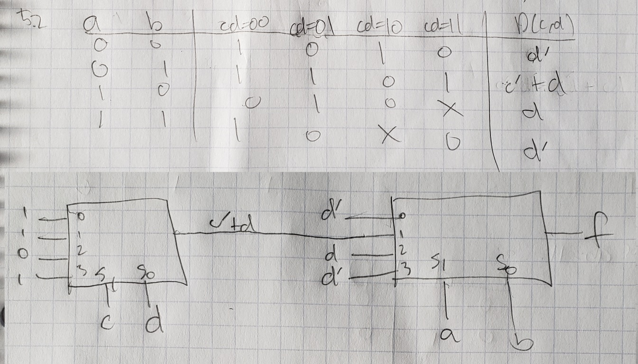

5.3)

